Mid Wales Media Hub
Social Media Content
November 2016
Twitter –
Date | Tweet | Additional content | Area(s)
07.11.16 | What did you get up to at the weekend? Was it #walking #eating, #exploring or staying in #MidWales ? bit.ly/2dFSB73 | n/a | Mid Wales
07.11.16 | Did you know the #GlyndwrsWay #NationalTrail is 132 miles long? That’s 696,960ft. bit.ly/2feA3cT | n/a | Mid Wales  Mid & North Powys
08.11.16 | Just because it’s getting colder doesn’t mean you can’t enjoy the #beach Plan a day out along the #Ceredigion #coast bit.ly/2frYfvd | n/a | Mid Wales  Ceredigion
08.11.16 | How about a #holiday in #MidWales with a difference? Why not stay on a farm? bit.ly/2esERtp #winterbreaks | n/a | Mid Wales
09.11.16 | Clip, clop. Ever tried exploring #MidWales on horseback? It can be an amazing experience. bit.ly/2fvaIdY | n/a | Mid Wales
09.11.16 | Fancy following in the footsteps of DC Mathias on #hinterland #ygwyll ? You can in #cambrianmountains #ceredigion bit.ly/2fITbEj | n/a | Mid Wales  Ceredigion  Cambrian Mountains
10.11.16 | Why not take your dog on #holiday in #MidWales A host of providers are able to put you and your pet up for a break. bit.ly/2feDFLP | n/a | Mid Wales
10.11.16 | Did you know #Wales #NationalLibrary is based at #Aberystwyth in #Ceredigion #MidWales ? bit.ly/2ftkAXo | n/a | Mid Wales  Ceredigion
11.11.16 | Friday Fact: Did you know the world’s first mail order company was located in #Newtown #MidWales ? | n/a | Mid Wales  Mid & North Powys
12.11.16 | It’s the weekend. What are you up to? There’s plenty going on in #MidWales #visitmidwales www.visitmidwales.co.uk | n/a | Mid Wales
13.11.16 | What’s your favourite image of #MidWales ? Why not tweet us your #coast or #countryside #holiday photos? | n/a | Mid Wales
14.11.16 | It’s #NationalEnterpriseWeek and we have so many enterprising #tourism destinations in #MidWales bit.ly/2edUshM | n/a | Mid Wales
14.11.16 | Exploring the #CambrianMountains couldn’t be easier on foot. There’s always a #B&B or #hotel at the other end. bit.ly/2dFSB73 | n/a | Mid Wales  Cambrian Mountains
15.11.16 | From cafes to fine dining. #MidWales is full of culinary surprises. bit.ly/2dXWtRx #visitwales #findyourepic | n/a | Mid Wales
15.11.16 | Two wheels are a great way to explore #MidWales, whether by mountain trail or road. bit.ly/2fHuNRZ | n/a | Mid Wales
16.11.16 | Did you know #MidWales was home to #Wales ancient capital in the #dyfivalley ? bit.ly/2ePpT4i #findyourepic | n/a | Mid Wales  Dyfi Biosphere
16.11.16 | There are over 1,200 miles of #cycleroutes in #Wales – many of which are in or pass through MidWales bit.ly/2fHqaHW | n/a | Mid Wales
17.11.16 | There couldn’t be anything more #festive than a #winterbreak in #MidWales bit.ly/2edUshM | n/a | Mid Wales
17.11.16 | Getting #married ? How about #MidWales as a #weddingvenue for your big day? bit.ly/2eoePfP | n/a | Mid Wales
18.11.16 | Friday fact: Did you know an average of 360 million litres of water leave the #ElanValley in #MidWales each day. bit.ly/2fA476n | n/a | Mid Wales  Mid & North Powys
19.11.16 | Head to the #Ceredigion #MidWales coast this weekend for some beachcombing. You never know what you might find. bit.ly/2edUshM | n/a | Mid Wales  Ceredigion
20.11.16 | Life is about experiences. And you’ll find plenty visiting #MidWales on a #winterbreak #findyourepic bit.ly/2fiLUck | n/a | Mid Wales
21.11.16 | It’s International #Sayhelloday, so why not say hi to some great #holiday #adventures in #MidWales ? bit.ly/2dhElTH | n/a | Mid Wales
21.11.16 | It might be nearer the start of the week, but have you planned the weekend yet? #visitmidwales #findyourepic bit.ly/2edUshM | n/a | Mid Wales
22.11.16 | Adventures really do start in #MidWales It’s just a case of finding the right one. bit.ly/2dUi7Dd  #findyourepic #shortbreaks | n/a | Mid Wales
22.11.16 | Thinking of a #winterbreak ? #MidWales is a great place for stunning scenic #walks with great accommodation bit.ly/2dhElTH | n/a | Mid Wales
23.11.16 | No matter what time of year or where you are in #MidWales, there’s a great #walk just up the road. bit.ly/2dFSB73 #findyourepic | n/a | Mid Wales
24.11.16 | Remember, you don’t need your passport when crossing #offasdyke into #MidWales bit.ly/2fO9IoE | n/a | Mid Wales  Mid & North Powys
24.11.16 | There’s always a chance of #wintersun along the #ceredigion #coast #shortbreaks #findyourepic #visitmidwales bit.ly/2edUshM | n/a | Mid Wales  Ceredigion
25.11.16 | Friday fact 1: The highest point in the #CambrianMontains is Plynlimon at 2,467ft bit.ly/2dFSB73  #findyourepic #visitmidwales | n/a | Mid Wales  Mid & North Powys  Cambrian Mountains
25.11.16 | Friday fact 2: Did you know #Aberystwyth ‘s pier was the first one built in #Wales – in 1865 #piers #visitmidwales #findyourepic | n/a | Mid Wales  Ceredigion
26.11.16 | Heading off this weekend? There are plenty of #adventures to be had in #MidWales | n/a | Mid Wales
27.11.16 | Whether you’re a #camping #caravanning #bedandbreakfast or #hotels person – MidWales has it all for #shortbreaks #findyourepic | n/a | Mid Wales
28.11.16 | Celebrate #NationalTreeWeek with some amazing woodland walks in #MidWales this winter. bit.ly/2dFSB73 #winterwalks #FindYourEpic | n/a | Mid Wales
28.11.16 | Did you know the Dyfi Valley is the only UNESCO Biosphere Reserve in Wales? bit.ly/2ePpT4i #findyourepic | n/a | Mid Wales  Dyfi Biosphere
29.11.16 | Can you guess where we were recently filming a tourism video in #MidWales ? #findyourepic | 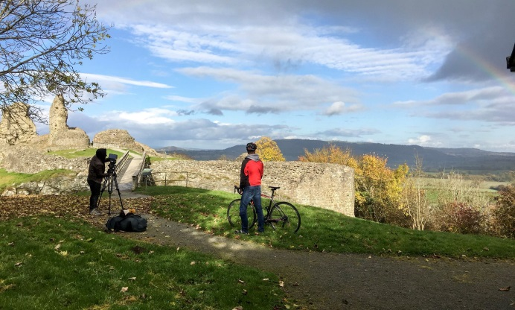 | Mid Wales
29.11.16 | There are plenty of hills to view the amazing views in #MidWales But have you ever conquered #ConstitutionHill in #Aberystwyth ? bit.ly/2ffDRyh | n/a | Mid Wales  Ceredigion
30.11.16 | Looking for a #winterbreak ? Whether a relaxing escape or an adventure, #MidWales has plenty to choose from bit.ly/2dFSB73 #findyourepic | n/a | Mid Wales
30.11.16 | The #SevernWayWalk is the longest river #walk in the #UK at 210 miles. And it starts in #MidWales bit.ly/2fA476n #findyourepic | n/a | Mid Wales  Mid & North Powys

