Mid Wales Media Hub
Social Media Content
September 2016
Date | Tweet | Additional content | Area(s)
05.09.16 | ICYMI: The Small is Beautiful festival is in Pantperthog this w/e. Tickets still available http://bit.ly/29lGg2r | n/a | Mid Wales  Mid & North Powys
 | ICYMI: Mae gŵyl Small is Beautiful ymlaen ym Mhantperthog dros y penwythnos. Tocynnau ar gael o hyd. http://bit.ly/29lGg2r | n/a | Mid Wales
06.09.16 | Want some #TuesdayTips on great days out in Mid Wales? We’ve got you covered http://bit.ly/2bXObqQ | n/a | Mid Wales  Mid & North Powys  Ceredigion
07.09.16 | The #ToB2016 is coming through #Wales today! Be part of this incredible #cycle #race as it goes from Denbigh to Builth Wells #FindYourEpic | n/a | Mid Wales  Mid & North Powys
 | Mae beicwyr #TOB2016 ar daith trwy Gymru heddiw! Ewch allan i’w cefnogi rhwng Dinbych a Llanfair Ym Muallt. #GwladGwlad | n/a | Mid Wales
08.09.16 | What’s #Wales famous for? #Castles! Why not explore some of our finest including Aberystwyth, @NTPowisCastle & @CardiganCastle #FindYourEpic | n/a | Mid Wales  Ceredigion
 | Mae Cymru enwog am ei chestyll. Beth am ymweld â rhai o gestyll y canolbarth @NTPowisCacstle a @CasAberteifi ac Aberystwyth? #GwladGwlad | n/a | Mid Wales
09.09.16 | Guided tours are a fab way to learn about some of Wales’ oldest sites, from #walking tours to chauffeur driven trips http://bit.ly/2cByIjt | n/a | Mid Wales  Mid & North Powys
 | Mae teithiau tywys yn ffordd wych o ddysgu am safleoedd hynafol Cymru. Dewiswch daith gerddedd neu daith mewn car. http://bit.ly/2cByIjt | n/a | Mid Wales
10.09.16 | This #weekend visit #Wales’ botanical #gin experts @DyfiDistillery using foraged goods to make great gin @biosfferdyfi #sustainable | n/a | Mid Wales  Dyfi Biosphere
 | Beth am ymweld â @DyfiDistillery yr arbenigwyr ar gynhyrchu gin botanegol sy’n cynnwyso cynnyrch wedi fforio @biosfferdyfi #cynaladwyedd | n/a | Mid Wales
11.09.16 | Make the most of our light evenings and pencil in some after work #walks. Try @GlansevernGrdns in Welshpool @MidWalesMyWay #FindYourEpic | n/a | Mid Wales  Mid & North Powys
 | Gwnewch yn fawr o’r nosweithiau golau gan fynd am dro ar ôl gwaith. Beth am @GlansevernGrdns yn Y Trallwng @MidWalesMyWay #GwladGwlad | n/a | Mid Wales
12.09.16 | Boots at the ready, #walks around the finest walking countryside in #Wales - Mawddach Estuary & Southern Snowdonia http://bit.ly/2crEmS3 | n/a | Mid Wales  Dyfi Biosphere
13.09.16 | Do you love to #paint? Workshops & courses both indoors & out. Book in advance to avoid disappointment @visitceredigion | n/a | Mid Wales  Ceredigion
14.09.16 | #Music lovers head to@aberystwytharts and checkout the local talent from the region. http://bit.ly/2coJVna Ceredigion - @visitceredigion | n/a | Mid Wales  Ceredigion
15.09.16 | #craft fans head to @NTLlanerchaeron and enjoy their Craft Fair and explore the great grounds @visitceredigion www.ccmcrafts.co.uk | n/a | Mid Wales  Ceredigion
16.09.16 | Fan of #TheLibrarySuicides? Attend an exclusive screening & Q+A with Director & Author @NLWales www.llgc.org.uk | n/a | Mid Wales  Ceredigion
17.09.16 | #Cycling fans! Will it be the Big Dog or Fun Route, get on your bike & hit the roads @ The Cambrian Coast Sportive http://bit.ly/1pJfhBR | n/a | Mid Wales  Ceredigion
18.09.16 | Renowned for its cracking atmosphere and Welsh hospitality head down to the Abergavenny Food Festival today #aff16 #SundayFunday | n/a | Mid Wales
19.09.16 | Marvel at the ‘The Wales & Border Ram Sale’ in its 37th year at the Royal Welsh Showground today http://bit.ly/2c1bQtJ #FindYourEpic | n/a | Mid Wales  Mid & North Powys
20.09.16 | Animals make excellent life models! Come and find out at the Animal #Sketching #Art Workshop http://bit.ly/2cn0QoY @visitceredigion | n/a | Mid Wales  Ceredigion
21..09.16 | #Music lovers! Listen to the sounds of @LynchedDublin, a traditional folk group @TheatrMwldan @visitceredigion http://goo.gl/yAzH3S | n/a | Mid Wales  Ceredigion
22.09.16 | #TrainSpotters can experience unique Victorian train travel in the original locomotive @TalyllynRailway #FindYourEpic | n/a | Mid Wales  Dyfi Biosphere
23.09.16 | Listen to Jack Lowe talk about his incredible  5-yr mission to photograph every lifeboat station in the UK @LIGCymru http://goo.gl/et2h0z | n/a | Mid Wales  Ceredigion
24.09.16 | No #WeekendPlans? Why not have a go at rustic furniture making at the @centre_alt_tech #Saturday #FindYourEpic https://goo.gl/UC8EU3 | n/a | Mid Wales  Mid & North Powys  Dyfi Biosphere
25.09.16 | Immerse yourself in #Welsh #History at #Britain's best preserved Victorian workhouse with music, film & much more. http://bit.ly/2bWm9ht | n/a | Mid Wales  Mid & North Powys
26.09.16 | #Congratulations @felinfahgriff for being named Welsh Dining #Pub of the year- start planning a trip #foodies http://www.eatdrinksleep.ltd.uk/ | n/a | Mid Wales  Mid & North Powys
27.09.16 | Visit Powysland Museum in Welshpool to see @ericgaskell1957’s incredible canal prints #exhibition #art | 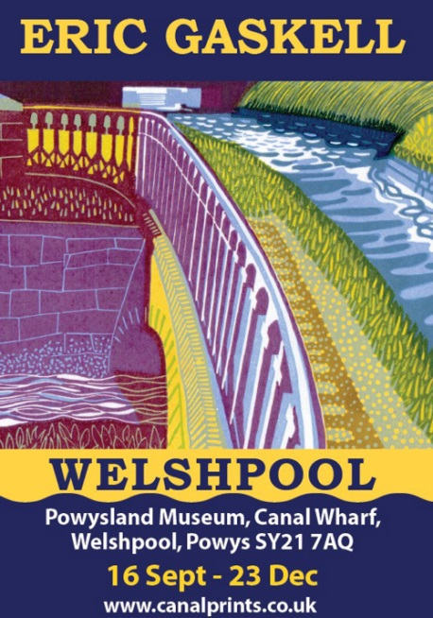 | Mid Wales  Mid & North Powys
28.09.16 | You can now download audible walking guides & discover a beautiful part of unspoilt Mid Wales https://afonleri.com/ #FindYourEpic | n/a | Mid Wales  Mid & North Powys
29.09.16 | Check out some of the great pictures from this year’s Tour of Britain which passed through Builth Wells #cycling https://goo.gl/G8tkYA | n/a | Mid Wales  Mid & North Powys
30.09.16 | Mid Wales is fab for dog-friendly holidays! Visit our website for hotel inspo that you and your #pets will love https://goo.gl/XEc1Pw | n/a | Mid Wales
01.10.16 | Looking for #WeekendWalk ideas? Check out @Elan_Valley in the Cambrian Mountains for stunning views and spectacular wildlife #FindYourEpic | n/a | Mid Wales  Mid & North Powys  Cambrian Mountains
02.08.16 | For something a bit different to your typical #Sunday lunch, try the fine dining experience @TheLlangoedHall #Welsh and #HomeGrown produce! | n/a | Mid Wales  Mid & North Powys

Facebook
04.09.16
In case you haven’t seen already, the incredible Small is Beautiful festival is taking place in Pantperthog this Saturday, and you can still get tickets! To find out about all the amazing talks, workshops and music on offer, visit https://www.eventbrite.co.uk/e/small-is-beautiful-festival-2016-tickets-26171762446
Facebook – 1 post a week
12.09.16
The School year is back into full swing but there is still a jam packed calendar of events for the whole family across Mid Wales. From farmers markets and food festivals to craft workshops and doggy friendly walks, there is something for everyone including your four legged friends.
For more information on events taking place this week across Mid Wales visit –http://www.visitmidwales.co.uk/events/thedms.aspx?dms=12&msg=&led=5&bf=1&w=100%25#!page=6
19.09.16
As we wave summer goodbye, we are welcoming autumn with open arms and making sure we’ve got plenty of plans lined up for the coming months. We are liking cosy craft events and foodie delights, alongside blustery woodland walks and visits to our gorgeous coastline. For inspiration and calendar planning visit our website;
http://www.visitmidwales.co.uk/events/thedms.aspx?dms=12&msg=&led=5&bf=1&w=100%25#!page=6
26.09.16
This week is all about great food, particularly great Welsh food and we are totally spoilt for choice across Mid Wales. With incredible fine dining options and good old pub grub, there is something for every type of foodie. Where’s your favourite place to eat out in Mid Wales? We’d love to know!

