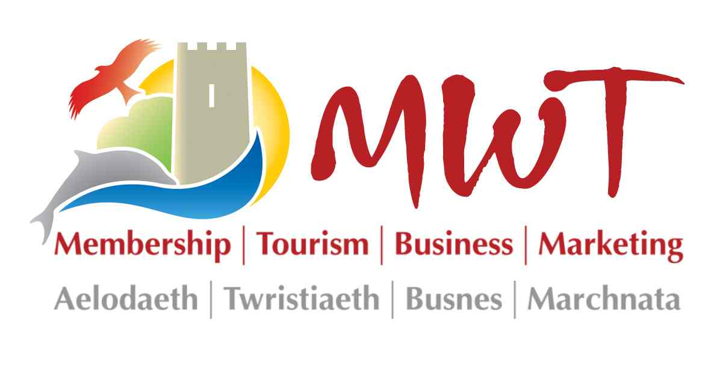

TWRISTIAETH CANOLBARTH CYMRU
MID WALES TOURISM

ADRODDIAD BLYNYDDOL 2014/15
ANNUAL REPORT 2014/15

Contents

P2 Foreword

P3 Board of Directors of Mid Wales Tourism

P4 Executive Summary

P5 Membership

P6 Marketing

P7 Contracts for Other Organisations

P8 Meet the Team

P9 Financial Summary

Foreword
The tourism sector in Wales annually hosts 10 million overnight stays and 89 million day visitors. 80% of income generated is from the UK market, mostly traditional family holidays.

MWT activities include support for individual businesses and organisations via membership services, industry representation, regional marketing and tourism project in collaboration with other tourism organisations.

As we reach the end of our 24th year of trading, Mid Wales Tourism (MWT) continues its vital work to support the tourism business community. As a ‘business-led’ organisation we are committed to delivering activities which support the growth and development of a strong and sustainable tourism industry.

Business re-structuring, undertaken to ensure that we are well–placed to support both members, and the wider tourism business community, has enabled the MWT to concentrate efforts in areas that provide the maximum support for our members.

Membership of the Wales Tourism Alliance enables MWT to represent members’ interests, and those of the wider tourism community at a National level and we provide support to local tourism groups and associations.

New this year, we have introduced a new marketing initiative working in partnership with other regions in the UK. Fairbooking™ Wales aims to encourage visitors to ‘Book Direct’ rather than through high commission channels.

MWT channels include Visit Mid Wales, Show Me™ Wales including app & mobile version, Wales Trails app, ‘dynamic widgets’, social media and in South & Mid Wales.

Our thanks to:
- All members for their continued support. It is pleasing to note that our membership figures remain strong with a growing number of businesses across South Wales also benefiting from MWT membership services.

- MWT staff for their hard work and commitment during the year; for the welcome and professional advice they give to our members.

- The Board of Mid Wales Tourism for their support and valued contribution across all areas of the business.

Providing tailored support to member businesses, delivering an excellent package of supplier discounts and investing in digital marketing has been the focus for our activities this year. Our dedicated team continue to deliver for you and the region and we welcome your support.
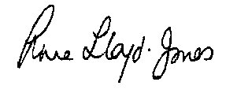Anne Lloyd-Jones
Chairman

The Board of Directors of Mid Wales Tourism
MWT is a Company Limited by Guarantee - it has no shareholders and is owned by its members. All profits are re-invested in the objects of the organisation. All Directors are non-executive.

MWT Directors are appointed to the Board on the following basis:

- 6 Trade Directors – 2 elected by members to serve for a period of 3 years from each of the three Local Authority areas of Mid Wales (Powys, Ceredigion & Meirionnydd)
- 3 Co-opted Directors – appointed by Board members
- 3 Local Authority Directors – 1 council nomination from each of the 3 Mid Wales Local Authority areas

During the year 2014/15, nominations for the appointment of Trade Directors in Powys resulted in Mr Calum Milne and Mr Neil Bale appointed to the Board.

We are grateful to all Board members, past and present, for their contribution to the well-being of MWT

Key objectives for which the organisation is established are:

MWT Board of Directors during the year under review are:

Trade Directors

Gwynedd
Anne Lloyd-Jones Chairman
William Moeran

Ceredigion
Paul Boland
Rowland Rees-Evans Vice Chairman

Powys
Calum Milne
Neil Bale (appointed Dec 14)

Co-opted Directors
Tony Bywater, MBE
Ian Rutherford
Vacancy

Local Authority
Vacancies

- To represent the interests of tourism operators and to provide services for them

- To assist in the promotion and development of the tourism industry in Wales

- To encourage the development and promotion of tourism in ways which are compatible with the need to protect the environment

- To promote Mid Wales as an area for holidays, business, travel and conventions directly and in conjunction with other organisations in the United Kingdom and overseas

- To engage in commercial activities which will support the foregoing objectives

Executive Summary – Review of the Year
Executive Summary - Review of the Year

Tourism membership and marketing is our core activity and this year we have focused our attention in making this even better.

Our primary aim is to support our members to gain and maintain competitive advantage in the marketplace. Exclusive supplier discounts and services, access to impartial support and advice and a continual programme of investment in the latest digital marketing technology help MWT members save time and money throughout the year.

Importantly, MWT provides an independent voice for the tourism business community. We continue to support the work of the Wales Tourism Alliance, lobbying for the recognition of the true value of tourism and for better support for tourism businesses.

Challenges this year have included re-positioning MWT to take account of new tourism structures, implemented by Visit Wales, following the winding up of the four Regional Tourism Partnerships in September 2014.

Overall, members have reported strong growth this year with visitor confidence returning, and we have also been delighted to welcome 48 new member businesses in the course of the year.

MWT 2014/15 highlights include:

- Significant increase in members utilising our one2one support services e.g website design services, one2one marketing reviews and members helpdesk support

- MWT tourism conference held in March 15 at the Metropole Hotel, Llandrindod Wells. Keynote speaker included Mr Ken Skates AM, Deputy Minister for Culture, Sport and Tourism and the event was well supported by Visit Wales, exhibitors and delegates.

- FairBooking™ Wales initiative introduced at our annual conference. Working with other UK destinations, MWT has taken the lead in Wales and will be supporting businesses to help encourage visitors to ‘Book Direct’ with accommodation providers.

In conclusion, 2014/15 our primary focus is to position MWT to enable the organisation to meet future challenges and opportunities, supporting our members and in partnership with other tourism organisations, help develop the tourism economy in Mid Wales and beyond.

Valerie Hawkins,
Chief Executive

Membership
Tourism membership provides businesses with an independent voice and a means to invest in a business-led partnership committed to supporting the growth and development of a strong and sustainable tourism industry in Wales. Working together is good for individual businesses and the industry as a whole.

MWT’s membership team are responsible for day-to-day administration and for the recruitment of new members. At the end of July 2015, MWT membership stood at 550 businesses.

Member businesses have access to an exclusive range of benefits and services including marketing opportunities, business benefits, regional & national lobbying and independent one-to-one advice.

Marketing for members
MWT invests in the very latest marketing technology providing members with a competitive advantage in the online marketplace. Members have access to both on-line and off-line marketing opportunities.

Save with affinity deals
Membership benefits and specialist suppliers are reviewed annually, ensuring that businesses get the best value possible.

Information, advice & support
Regular communication with members via e-newsletters, social media, local trade meetings, annual conference, corporate website www.mwtcymru.co.uk and our members helpline means that help and advice is always close at hand.

An independent voice for the tourism business community
MWT represents tourism businesses regionally and nationally through the Wales Tourism Alliance.

‘Show Me™ Wales’
Trading name used for our marketing activities
“A strong industry-led organisation is vital for the maintenance of a strong and stable tourism industry – one that contributes so much to the economy of Wales.”
Membership for all Tourism Businesses and Organisations:

Hotels
Bed and Breakfast
Guesthouses
Farm Accommodation
Self Catering
Groups & Hostels
Holiday Parks
Camping & Touring Glamping
Visitor Attractions
Activity Centres
Cafes
Restaurants
Inns
Retail Outlets
Self Catering Agencies
Marketing Consortia
Tourism Associations
National Organisations & Local Authorities
Community Groups
Corporate / Commercial
Tour Operators & Guides
Coach Companies
Event Organisers

Marketing
MWT invests in the very latest digital technology and online channels include visitmidwales.co.uk, Show Me Wales and app channels. FairBooking™ Wales is a new initiative introduced in 2015.
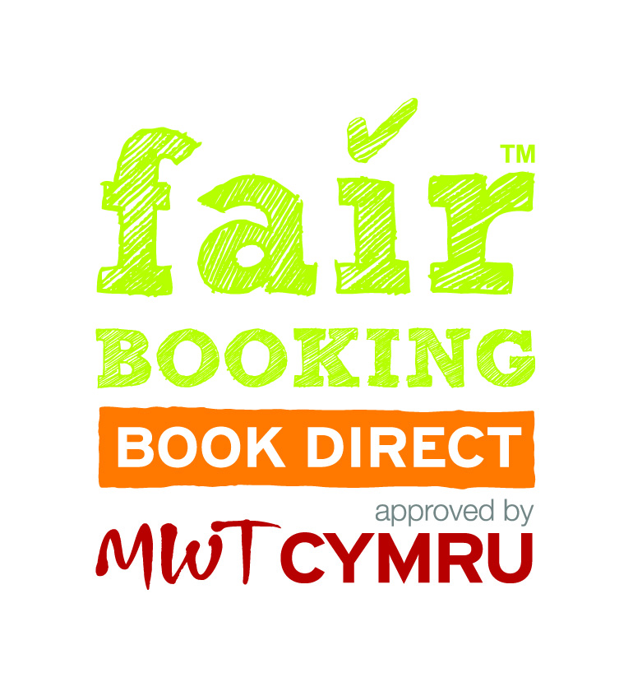
FairBooking™ Wales

Fairbooking™ is an international initiative aimed at helping visitors make ethical booking choices, encouraging more visitors to book direct with accommodation provider.

This initiative has been introduced in Wales by MWT as FairBooking™ Wales. Businesses that join the initiative commit to providing the Best Deal for their visitors that Book Direct. For every booking a provider receives, a minimum of 50p is donated to a chosen charity.

MWT Guestlink Helpdesk

MWT Guestlink Helpdesk provides expert advice and support for all MWT members and Guestlink+ services users.

Working with partners to increase the number of distribution channels for members remains a priority. Guestlink channels now include national channels, third party websites, ecommerce solutions, white label solutions, data feeds, digital print, web booking for individual sites and affiliate marketing channels

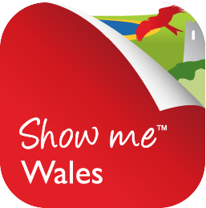
‘Show Me™ Wales’

Show Me Wales is a family of channels, including app & mobile, supporting host of features. The main website hosts all our itineraries, widgets, Wales Trails travel section, destinations, venues, & special occasions.

Widgets are plugins which are used to populate host/businesses own websites with information. Things to do, events or places to stay widgets are available in different formats including search, eshop, map, list or slider. Businesses can update details across all channels in real time via Guestlink.
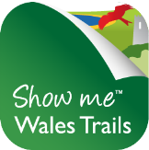
Show Me Wales Trails is a travel tourism initiative aimed at encouraging visitors to explore Wales car free. Wales Trails app features Wales Coast Path, national walking and cycle routes and scenic rail trails all linking to things to do and places to visit.

Days out in Mid Wales
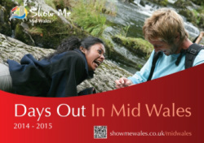
‘Days Out in Mid Wales 2014/15 - Eight thousand copies distributed to all members offering accommodation. Reference copies are sent to TIC’s throughout Wales and other selected locations. This publication is supported by attraction and activity businesses, tourism organisations and associations.
Projects in Collaboration with other Organisations

MWT specialises in the management and delivery of tourism related projects which include business development and networking, regional marketing and promotion, digital marketing, database management, events marketing and campaign management.

E-Commerce and distribution channels

MWT Guestlink Helpdesk provides support for all businesses and organisations using Guestlink ecommence options and distribution channels. We also provide support to local authority tourism teams that use the NVG system.

Visit Wales Official Data Partner
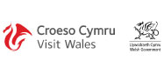
MWT is the official Visit Wales Data Partner, providing Guestlink Helpdesk support for businesses across South and Mid Wales that wish to update their basic WTPD (Visit Wales) listing.

Both ‘NVG’ and ‘Guestlink’ are part of the Tourism Media Group that specialise in tourism solutions for businesses and destinations.

Visit Wales – Regional Support

Visit Wales re-organisation of regional tourism support has resulted in the winding up of the Regional Tourism Partnerships on October 2014.

As part of this re-organisation, Visit Wales has introduced a Grant Support Scheme (RTEF) are encouraging local areas (destinations) to develop collaborative projects.

A new Visit Wales Regional Tourism Forum has also been set up which meets quarterly and includes representatives from local areas (destinations) across the Mid Wales region.

Car Free Adventures – RTEF Funded Project

MWT successfully applied for grant support in partnership with Dyfi Biosphere to deliver a co-ordinated programme of activities.

The project aim is to generate a step-change in how visitors travel to and around the Mid Wales area, enabling and encouraging visitors to make greater use of low impact travel options.

A new travel brand will be developed and a toolkit will provide businesses and organisations with help to incorporate travel options within their own marketing.

Meet the Team
Val Hawkins – Chief Executive is responsible for leading and taking the Company forward and overseeing delivery of all projects managed by MWT. Val leads on some of our major contracts. She is also the Company Secretary.

Zoe Hawkins – Zoe is responsible for the co-ordination and delivery of all MWT digital projects. Zoe commenced maternity leave at the end March and gave birth to a baby girl in April.

Sioned Pugh – Sioned joined the team in March 15 with responsibility for Membership & Networks.

Gemma Howells – Gemma was appointed as Sales Administrator in January 15 and is on maternity leave following the birth of a baby boy in May.

Temporary Appointments: Hari Wyn Williams was appointed in April 15 on a six month contract to cover for maternity leave and Davina Roberts has helped with administration support.
Company Accountants and Solicitors

Company Solicitors Company Accountants

Morris & Bates PJE – Chartered Accountants
P.O. Box 1 23 College Street
Alexandra Road Lampeter
Aberystwyth Ceredigion
SY23 1PT SA48 7DY

Mid Wales Tourism is a Company Limited by Guarantee
Registered in Wales No: 2612356
Registered office: The Station, Machynlleth, Powys, SY20 8TG
Tel No 01654 702653 Fax 01654 703235

Consumer Website: www.visitmidwales.co.uk & www.showmewales.co.uk

Corporate Website: www.mwtcymru.co.uk

Social Media Channels

Consumer
Facebook.com/showmewales
Twitter.com/showmewales

Corporate
Facebook.com/mwtcymru
Twitter.com/mwtcymru

Financial Summary

